

**User Manual**

Admin GUI

**Louisiana Tech University**

**Table of Contents**

1. Introduction
   1. Purpose
   2. Scope
   3. GUI Organization
2. Describing the GUI
   1. Key Features
   2. Tab Descriptions
3. Step by step Instructions for using the GUI
   1. Tab Instructions
   2. Errors and Malfunctions
   3. Messages
4. Appendix A – Tab Screen Shots
5. **Introduction**
   1. Purpose

This program provides the admin(s) a graphical interface to the scoring server.

* 1. Scope

The Admin GUI allows the user to take a look at the current state of the database. It also provides a way to interact with the competing teams through announcements and challenges. The score can be updated manually through this interface.

* 1. GUI Organization

The GUI is presented in one webpage that separates each section into different tabs located at the top of the page.

1. **Describing the GUI**
   1. Key Features
      1. Provides summary: Current Score, Challenges won per team, list of Announcements, and list of previous/current Challenges
      2. Update team(s) score
      3. Add Announcements to be displayed to teams/audience
      4. Create Challenges to be displayed to teams/audience
      5. Close previous Challenge and display winning team(s)
      6. Provides snapshot of events in the database
      7. View Real-Time Scoring Flash Display
   2. Tab Descriptions
      1. Summary
         1. Snapshot of Teams database table
            1. Attributes: team name, color, current score, and number of challenges won
         2. Snapshot of Announcements database table
            1. Attributes: ID, message, time created, length of time displayed
         3. Snapshot of Challenges database table
            1. Attributes: ID, name of challenge, team winner, points, message, start time
      2. Scores
         1. Drop-down menu containing Team names
         2. Textbox for entering points (negative points accepted)
         3. Textbox for entering message
         4. Update Scores button
      3. Announce
         1. Textbox for entering announcements
         2. Announce button
      4. Challenge
         1. Create
            1. Textbox for entering challenge name
            2. Textbox for entering points associated with challenge
            3. Textbox for entering message to be displayed announcing Challenge
         2. Close
            1. Snapshot of Challenges database table

Attributes: ID, name of challenge, team winner, points, message, start time

* + - * 1. Button to Announce Winner of challenge
    1. Event Log
       1. Snapshot of Events database table
          1. Attributes: ID, team name, type of event, points, message, timestamp
    2. View
       1. Real-Time Flash scoring front-end displayed

1. **Step by step Instructions for using the GUI**
   1. Tab Instructions
      1. Scores
         1. Choose team name from drop-down menu
         2. Enter point amount
            1. Integer only for positive points
            2. Negative sign (-) before integer for negative points
         3. Enter message to be recorded in database and displayed on the scoring front-end
         4. Press ‘Update Scores’ button to submit to database
      2. Announce
         1. Enter announcement message in textbox
         2. Press ‘Announce’ button to submit message to database
      3. Challenge
         1. Create
            1. Enter name of challenge
            2. Enter point amount
            3. Enter message to be recorded in database and displayed on scoring front-end
            4. Press ‘Start Challenge’ button to submit to database
         2. Close
            1. Choose which challenge to close in the list and press the ‘Announce Winner’ button
            2. Select team winner in drop-down menu
            3. Press ‘Announce’ button to submit challenge winner to database
            4. Or press ‘Cancel’ button
      4. Event Log
         1. Enter text in the search bar to search all of the fields in the database table
         2. Click down or up arrow in a field to sort the entries by that specific field
         3. Click right or left arrow to move through the entries
         4. Drop-down menu in top left allows you to select the number of entries shown per page: 10, 25, 50, or 100
   2. Errors and Malfunctions
      1. Points Textbox
         1. Must enter an integer in Points textbox on Score and Challenge-Create tabs
         2. If positive – no sign before integer
         3. If negative – need ‘-‘ before integer
      2. Other Textboxes
         1. Cannot be empty when submitting a Score, Announcement, or Challenge
      3. Webpage
         1. Will not load – server down; try again later
   3. Messages
      1. Display actions initiated by buttons
         1. Score Added
         2. Announcement Made
         3. Challenge Started
         4. Challenge Ended
2. **Appendix A – Tab Screen Shots**
   1. Summary

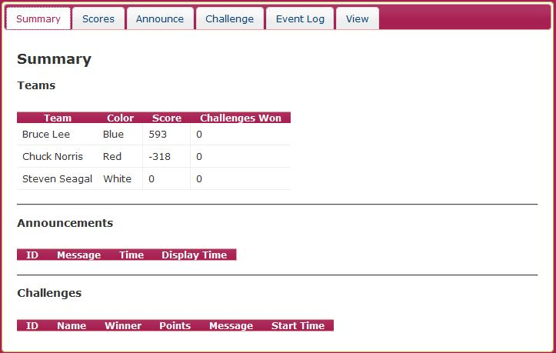

* 1. Scores

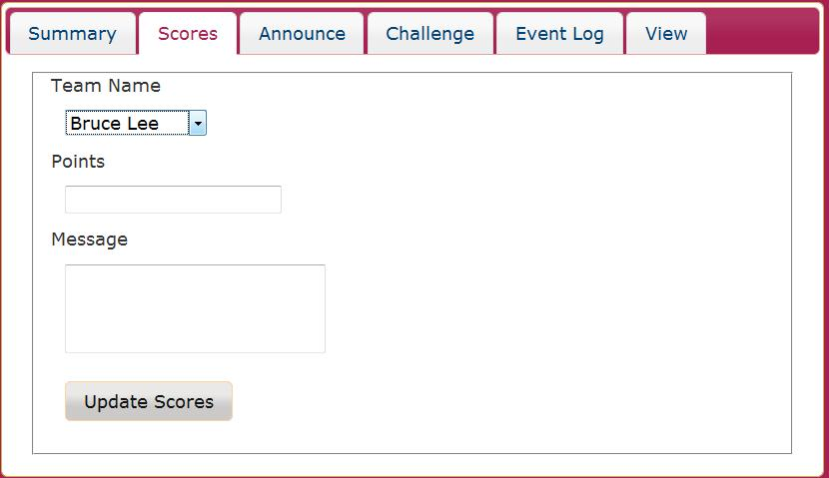

* 1. Announce

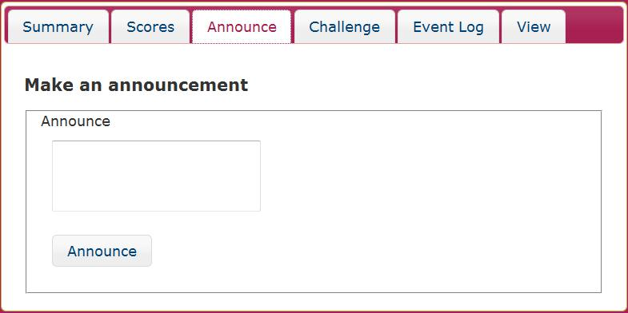

* 1. Challenge
     1. Create

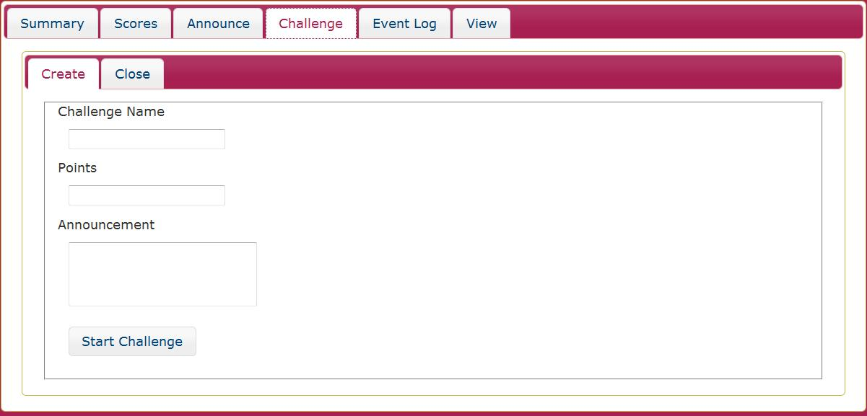

* + 1. Close

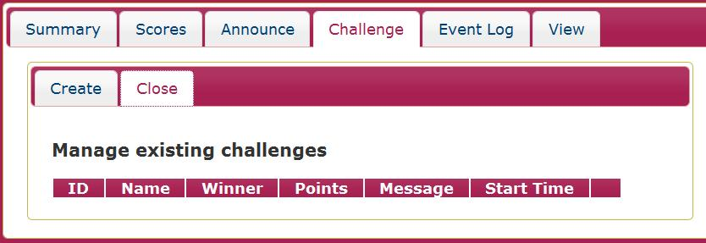

* 1. Event Log

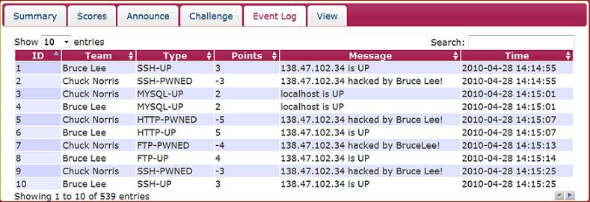

* 1. 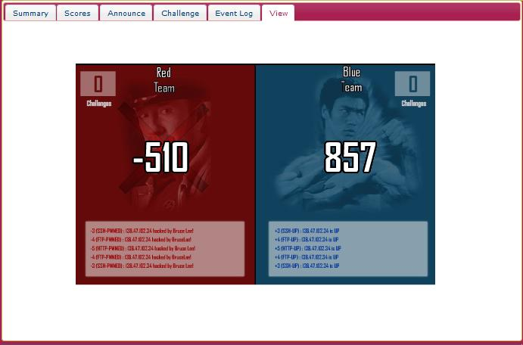 View